**Implementation assignment #1**

**Subject = Operating Systems Design**

**Major = ITM**

**Student ID = 17102062**

**Name = Lee Yong Hoon(이용훈)**

Execution screenshots

|  |  |
| --- | --- |
| Compile and runs the program | The shell program can compile and run successfully |

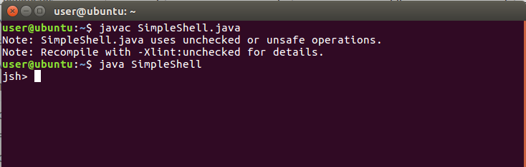

|  |  |
| --- | --- |
| ProcessBuilder object | ProcessBuilder object is correctly created, ps, ls, and cat command works |

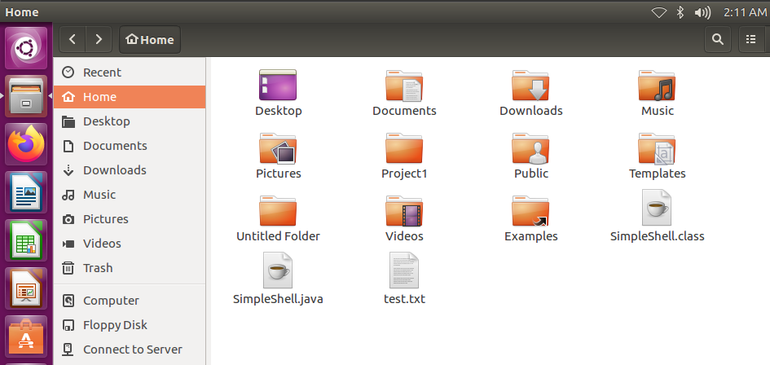

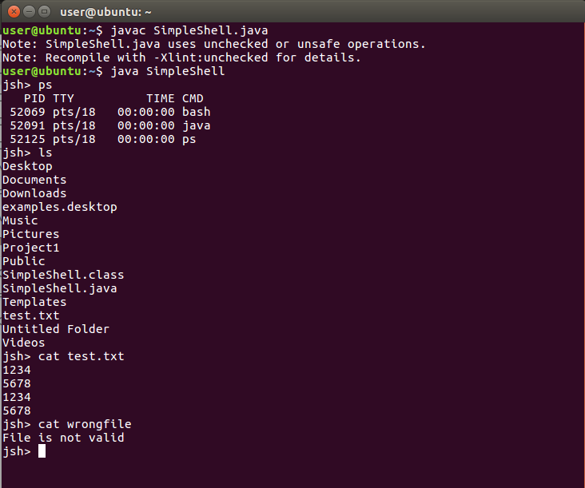

|  |  |
| --- | --- |
| Exit and quit | Exit and quit works |

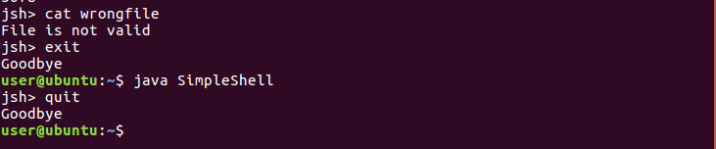

|  |  |
| --- | --- |
| Change directory to /home/user | **cd** followed by **pwd**  You are able to change directory to /home/user directory and display it. (absolute path is working) |

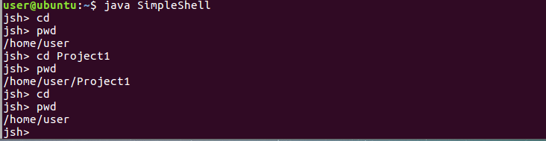

|  |  |
| --- | --- |
| Handle absolute path | **cd /home**  You are able to change directory to /home |

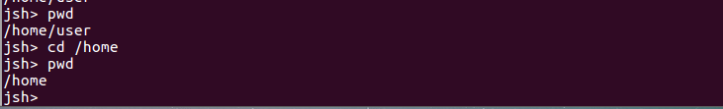

|  |  |
| --- | --- |
| Relative path | then **cd user**  You are able to change directory to /home/user (relative path is working) |

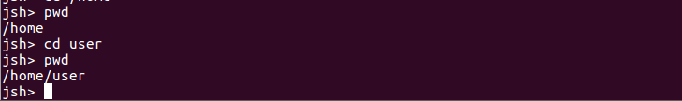

|  |  |
| --- | --- |
| Relative path | Go back to /home then  **cd ./user/Project1 , cd user/Project1,** or any existing folder  You are able to change directory to /home/user/Project1 |

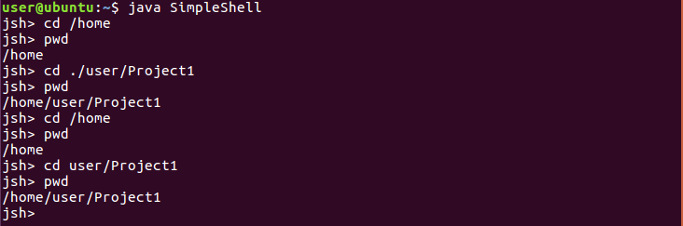

|  |  |
| --- | --- |
| Relative path | cd ..  You are able to change directory to /home/user |

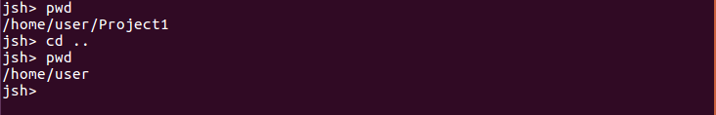

|  |  |
| --- | --- |
| Error handling | **cd fakeDirectory**  Error message for invalid path |



|  |  |
| --- | --- |
| history | ‘history <number>’ works well |

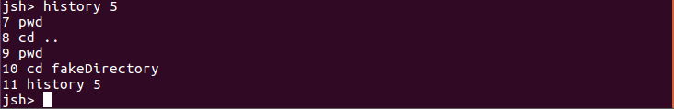

|  |  |
| --- | --- |
| history | ‘history !!’ works well |

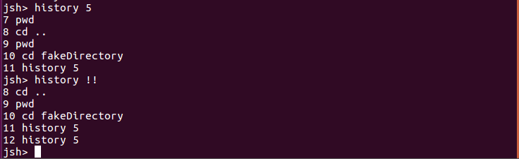

|  |  |
| --- | --- |
| history | ‘history !<number>’ works well |

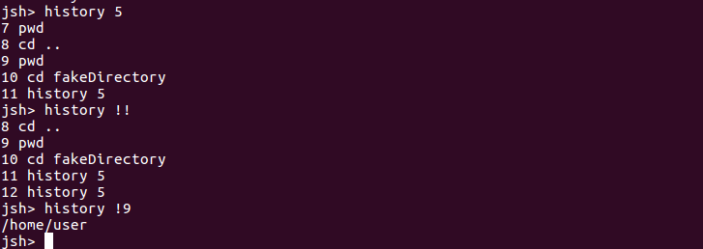

|  |  |
| --- | --- |
| 1-5 questions |  |

1. How far did you get in this project? What grade are you expecting? Did you find the milestones in the description helpful? Do you think you could have gotten the project working as well as you did without the milestones?

**All given cases have been implemented. If there is no problem with error or exception handling, expect A score. The milestone in the explanation was a big help, and without it, it would have taken longer, but I think the project would have been completed eventually completed.**

1. Do you feel like a better programmer now that you’ve completed this project? How does this compare to programming project that you’ve had in prior class?

**In terms of importing and utilizing new features, it was much more interesting than the previous project and helped improve coding skills. The previous project also helped me improve my skills, and I think it would be good to run these programming projects often.**

1. Describe 3 problems (relating to this assignment) that arose while you were working on this project and explain how you solved them.

**1.Process starting error when execute cd and history.**

To solve this problem, I move cd and history code before process starting code. And when cd and history execute and finished, by using continue, avoid going to process starting with cd and history command

**2.Check directory is valid in cd function**

I did not know exist function, so I had problem to check whether directory is valid.

After googling, I can find exists function.

File file = new File(path);

Using File and with file, I can use exist function.

**If(file.exists()){**

**Return path;**

**}**

**3.When write invalid command, program is quit.**

To control invalid command, I use try and catch.

1. How long did you spend on this assignment? Give me specifics. For example:

|  |  |  |  |
| --- | --- | --- | --- |
| **Date** | **Time** | **Activities** | **Outcomes** |
| 3/17 | 3hours | Study ProcessBuilder + code 1~9 |  |
| 3/19 | 2hours | Code cd, history, !! and !<Integer> |  |
| 3/20 | 3hours | Change windows command to Linux command |  |
| 3/20 | 2hours | Check code, make comment, make report |  |

1. Total hours spent. Try to be honest and do not exaggerate here.

**studying about ProcessBuilder and making code take about 8 hours**

**Checking my code, making comment and making report take about 2hours**

**Total hours is 10 hours.**